Practical 4
Compile time
A compile-time error is an error that occurs when you compile a program, before it actually runs.
It means the compiler (like GCC for C/C++) finds something wrong in your code’s syntax, structure, or type rules, so it cannot convert your source code into machine code.

Missing colon
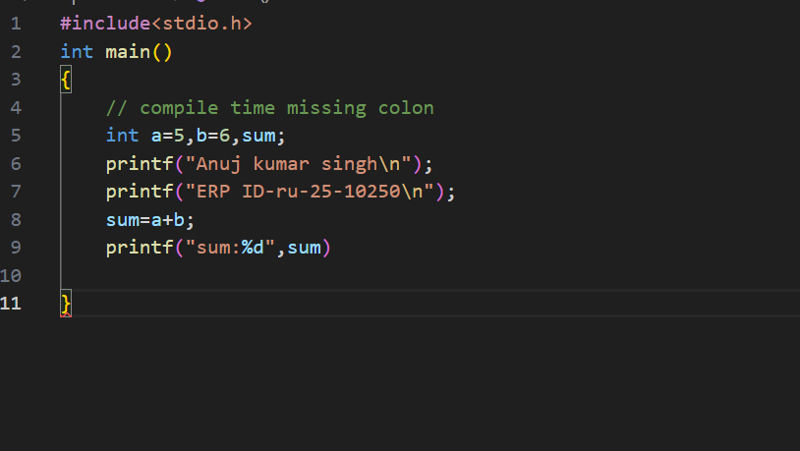
Output:
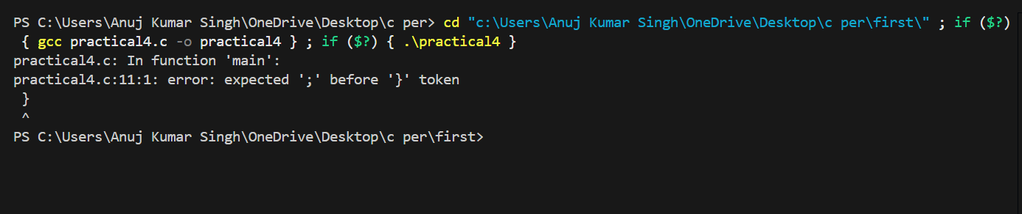
Format specifiers
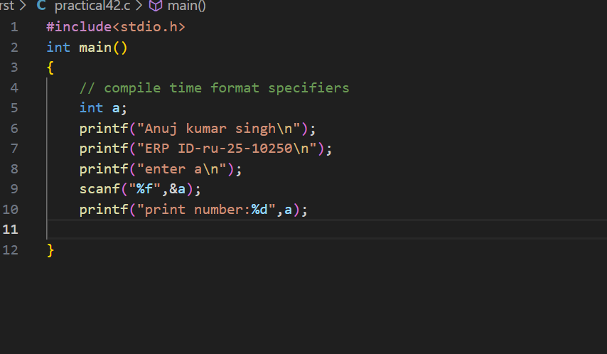
Output:
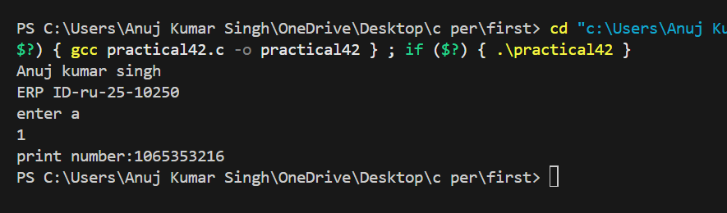
Variable declared
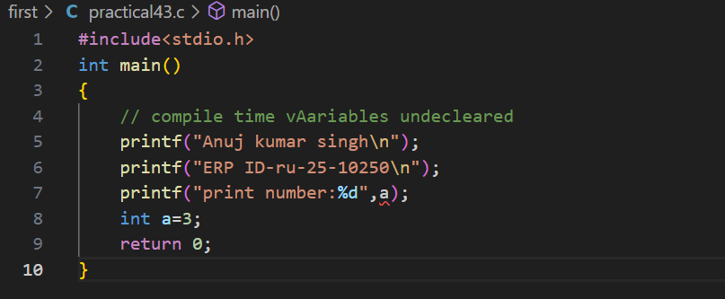
Output:
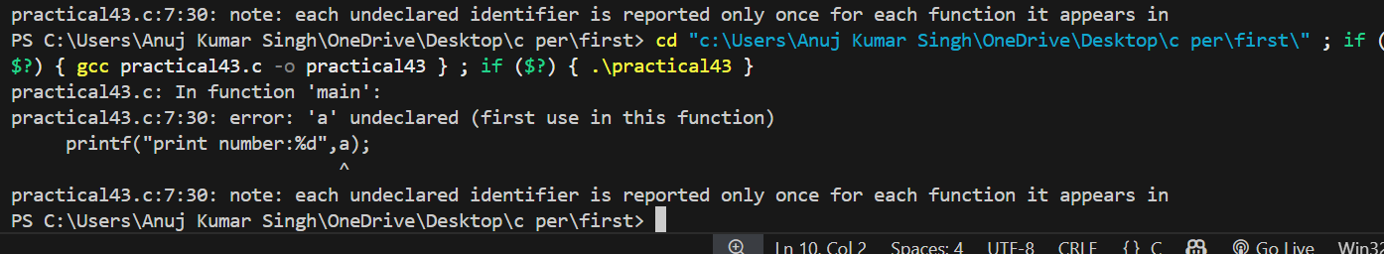
Redeclared variable error
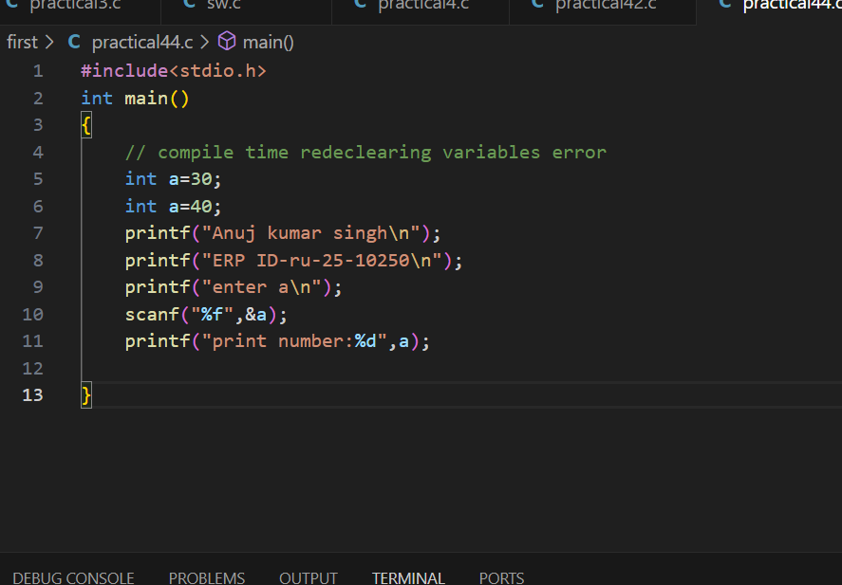

Output:
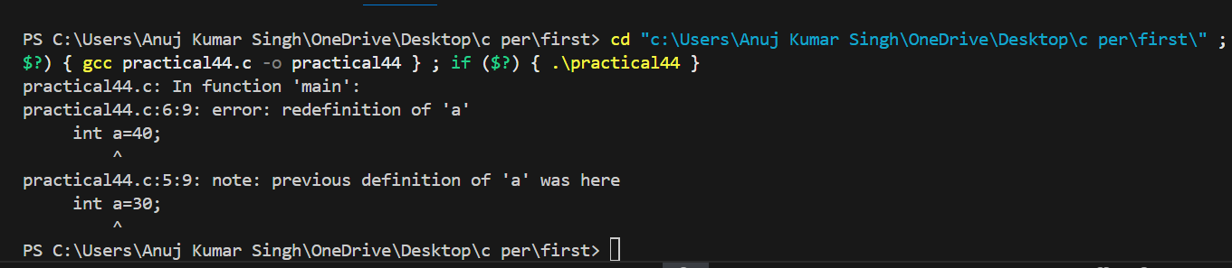

RUN TIME:
A runtime error occurs while the program is running, after it has successfully compiled.
That means the compiler didn’t find any syntax mistakes, but something goes wrong when the program executes — like invalid operations or memory access issues.

Divide by 0
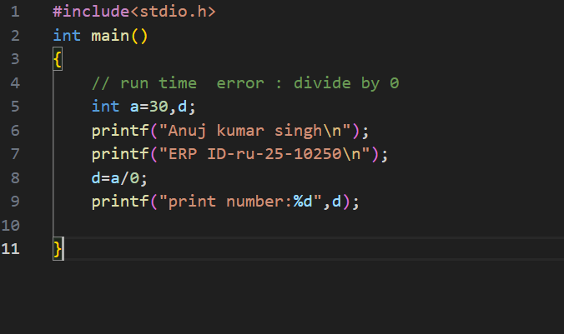
Output:
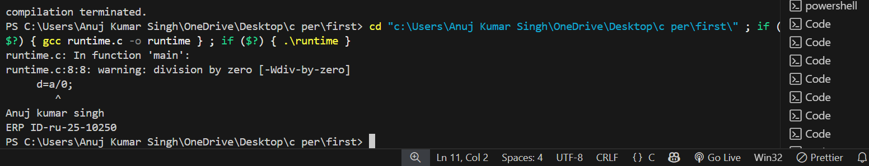
Segmentation fault
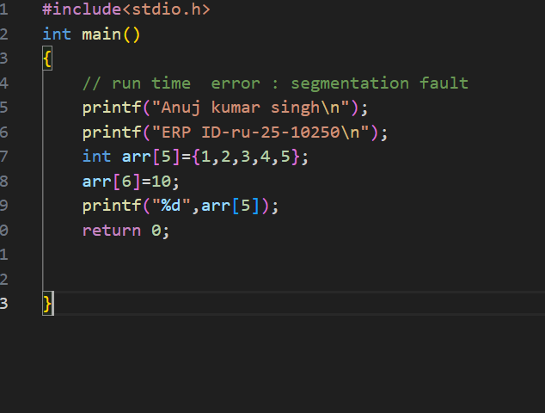

Output:
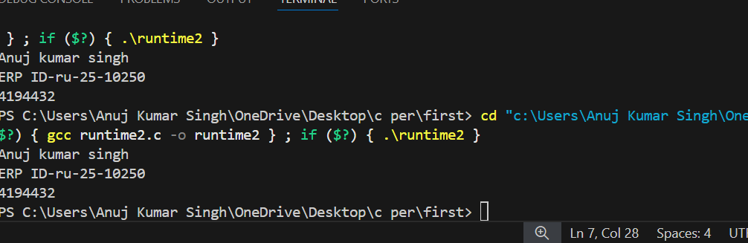

INFINITE LOOP ERROR:
An infinite loop error happens when a loop in your program never ends — it keeps running forever because the loop condition never becomes false.
It’s not exactly a compiler error (since the code is syntactically correct), but a logical or runtime error, because the program gets stuck and never stops running.

